Malawi Update

March 4, 2022

Bicyclesformalawi

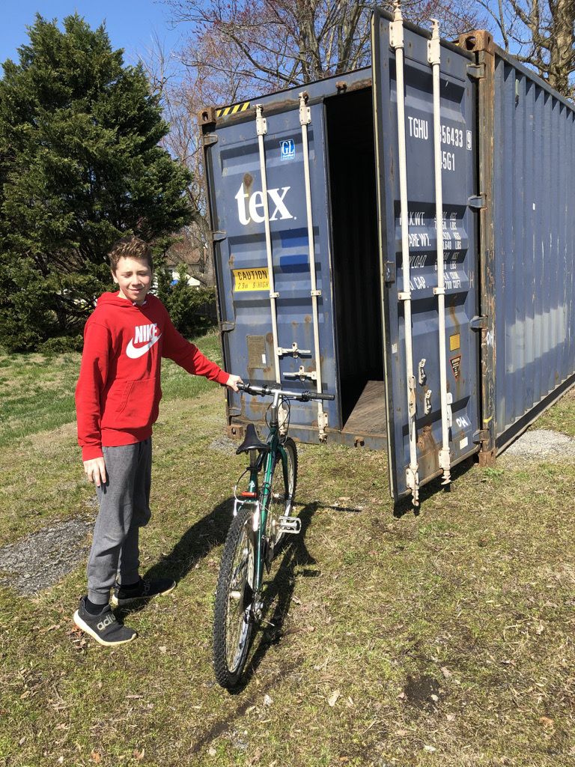
O
ur big blue shipping container in the church parking lot is filling up fast! We are so thankful for God’s provision and everyone’s generosity.
Our goal is to complete our collections and have the container ready for shipment by the end of March. Here is what we still need and how you can help!
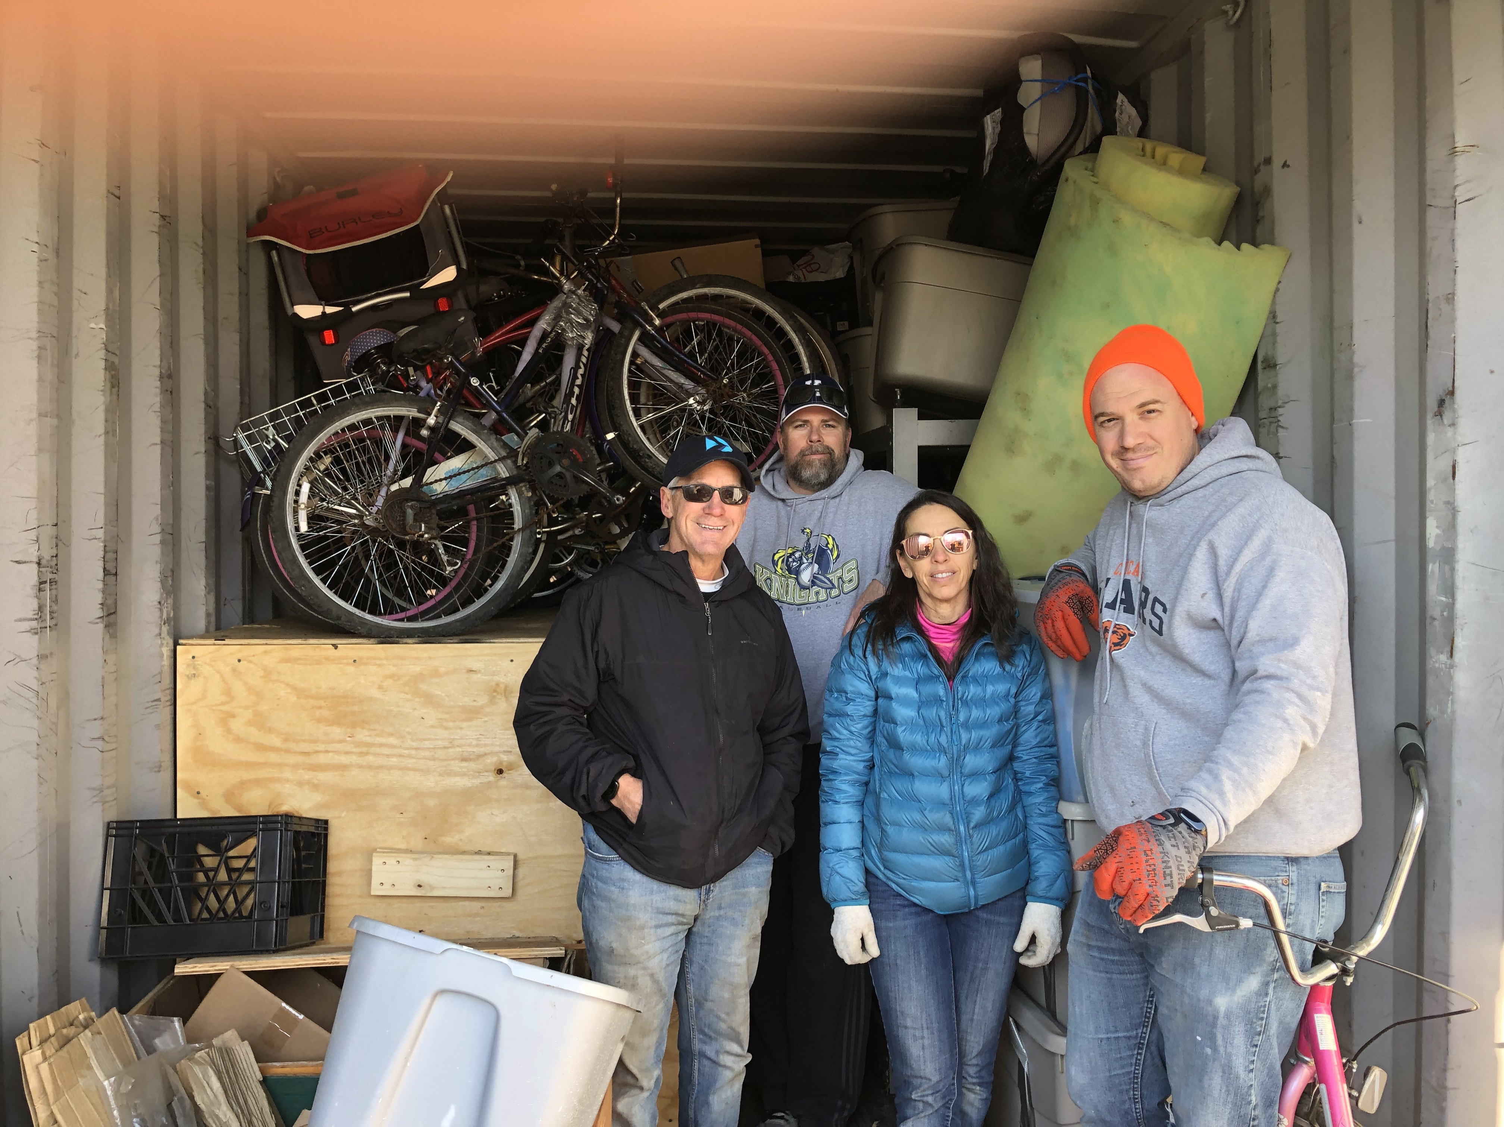
Bikes! Bikes! And more Bikes! We can still accommodate another 50 or so bicycles and we would welcome any spare parts for bicycles, like chains, and tool etc.
Portable generator! Pastor Robert’s New Life Church and the Pastoral Training Institute still do not have electricity on campus. A 5000+Watt portable generator would be a huge blessing to provide for the sound system and lighting needs of the congregation as they gather for Sunday worship and week night prayer and bible study. It would also enable the pastors in training to extend their study times into the evening hours.
We are also supporting vocational training programs including sewing, welding, carpentry, for youth at Seeds of Promise and other UrbanPromise affiliated ministries so we welcome any contributions of sewing and welding machines along as well as hand and power tools for wood and metal working programs.
Children’s Books! There is a scarcity of books for the children. Our ministry partners are all involved children’s educational programs and would love any to receive books of any size for any age to help in their promotion of reading and creating lifetime learners. English is taught in the schools along with the local language.
You can also make a financial contribution to support the bicyclesformalawi project and our ministry partners in Malawi. Donations online can be made at https://wccpc.org/give/ by using the designated tab for Bike Project.
Checks can be made out to White Clay Creek Presbyterian Church with bicyclesformalawi designated on the memo line and sent to 15 Polly Drummond Hill Road Newark, Delaware 19711
You can learn more by visiting our website at https://www.bicyclesformalawi.com or our church’s missions webpage at https://wccpc.org/missions/missionary-detail/bicycles-for-malawi/
Items for donations can be scheduled for pick-up or drop-off by sending us an email at bicyclesformalawi@gmail.com
All donations to bicyclesformalawi are tax deductible!

